**ECSE 543 A3**

**Q1**

**a)**

The implementation of Lagrange polynomial interpolation is attached in the Appendix. Figure 1 shows the interpolation with the first six points, and the result is not plausible. The points after the first six ones do not lie closely to the curve.

Figure - Q1 a)

**b)**

Figure 2 shows the interpolation with the selected six points, and the result is still not plausible.

Figure - Q1 b)

**c)**

The implementation of cubic Hermite polynomial interpolation is attached in the Appendix. To make the curve smoother between subdomains, the slopes at the subdomain connection points are forced to be continuous, which is shown in Figure 3. The result of the interpolation is shown in Figure 4, which lies closely to all the given data points, thus it is a plausible interpolation.

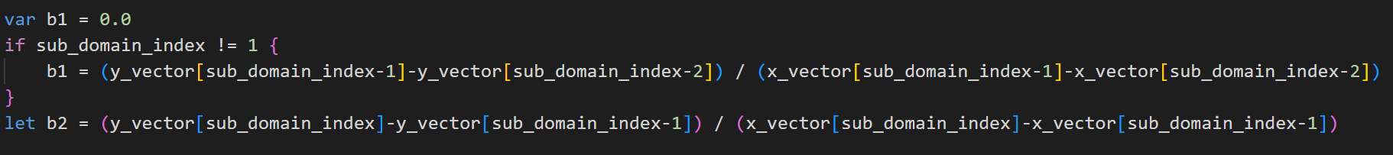

Figure - Smooth Slope

Figure - Q1 c)

**d)**

**e)**

Newton-Raphson method is implemented and is attached in the Appendix. Since only B is given, but the actual required values are flux, where flux = B*A, A = 1cm2; thus, the B vector is multiplied by 1e-4, to convert it to flux, which is shown in Figure 5.

The flux result (1.6127e-4 Wb) and the number of iterations is shown in Figure 6.

Figure - Update Flux

Figure - Newton Raphson Results

**f)**

The Successive Substitution is implemented, as shown in Figure 7. This method initially did not converge. After reducing the step size of value updating, as shown in Figure 7, this method finally converges. The result is shown in Figure 8, which is close to the result of the Newton-Raphson method.

Figure - Successive Substitution with Smaller Step



Figure - Successive Substitution Result

**Q2**

**a)**

**b)**

The Newton-Raphson method for Q2 is implemented and is attached in the Appendix. The final node voltages and the values of **f** and node voltages at each iteration is shown in Figure 9. To show the rate of convergence, delta_x is also recorded and plotted, as shown in Figure 10. Although there is not a clear trend of convergence being quadratic (took only 5 iterations to converge), the rate of convergence can be concluded to be fast (only 5 iterations).

Figure - Newton Raphson Results for Q2

Figure - Rate of Convergence

**Appendix**

**Lagrange Polynomial Interpolation**

**Cubic Hermite Interpolation**

**Newton Raphson (with Piecewise Interpolation)**

**Successive Substitution**

**Newton Raphson for Q2 (with Jacobian)**

**Testing**

